1. **Staff Login Page - Secure authentication interface**

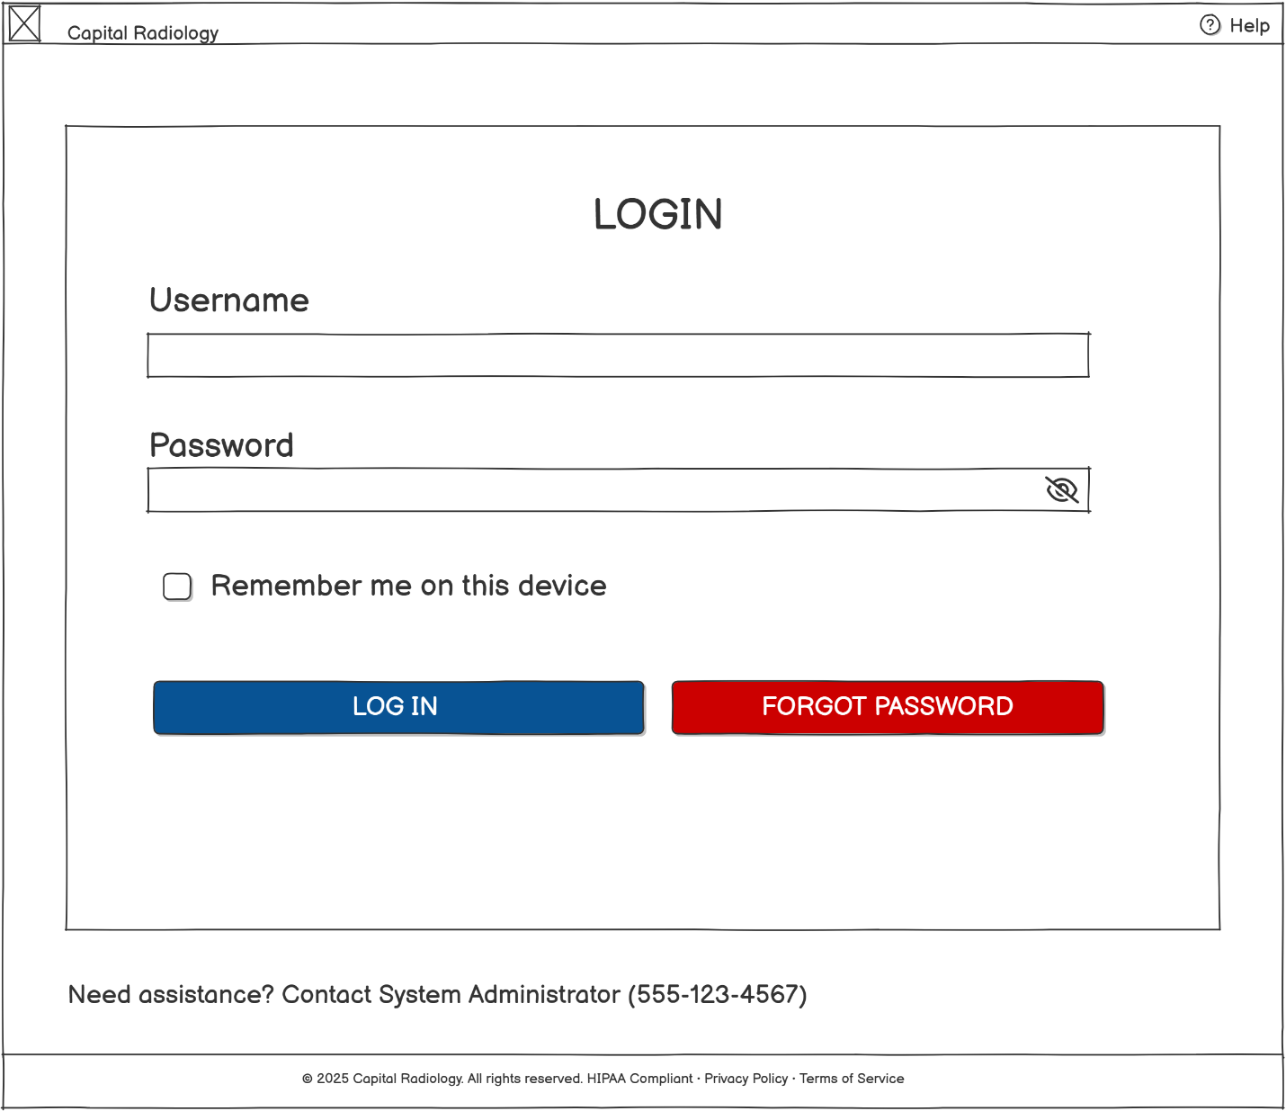

1. **Staff Dashboard - Daily tasks and notifications overview**

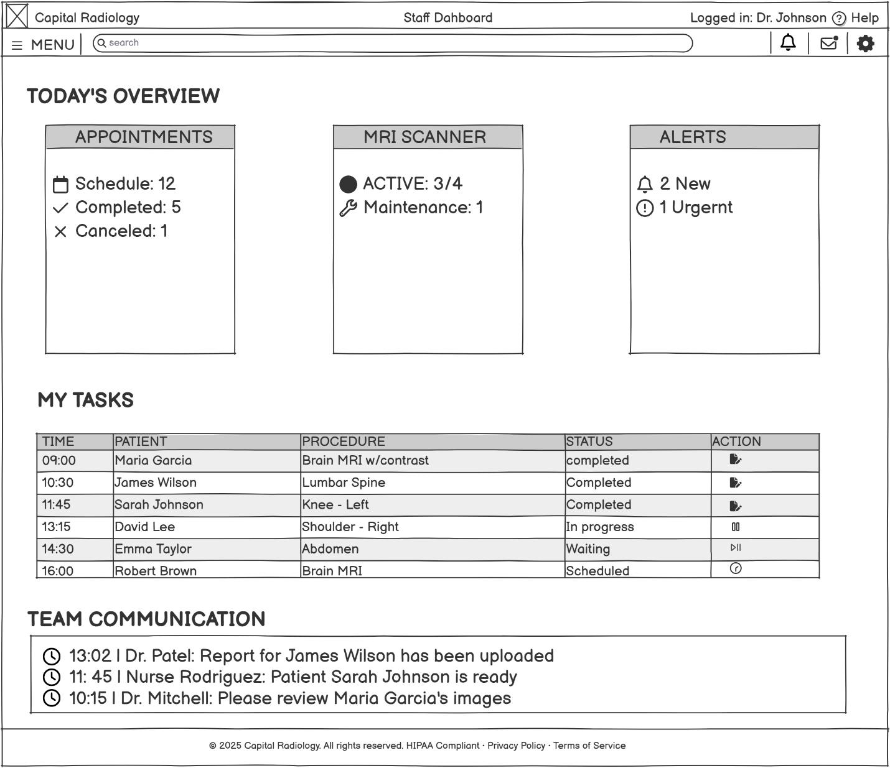

1. **Equipment Management - MRI machine status and maintenance**

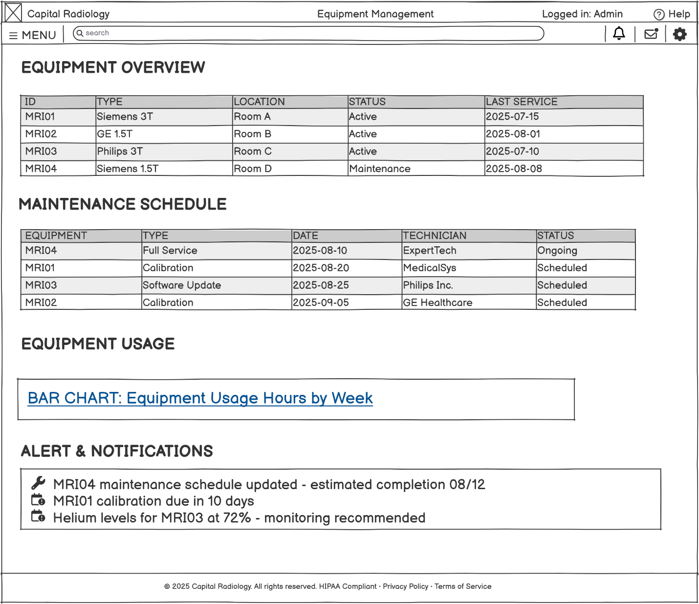

1. **Internal Messaging - Staff communication system**

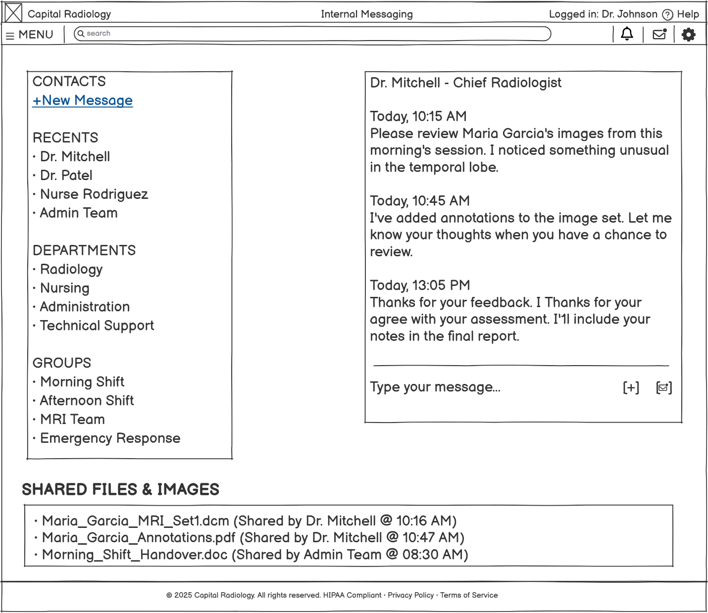

1. **Input Form: Staff login form**

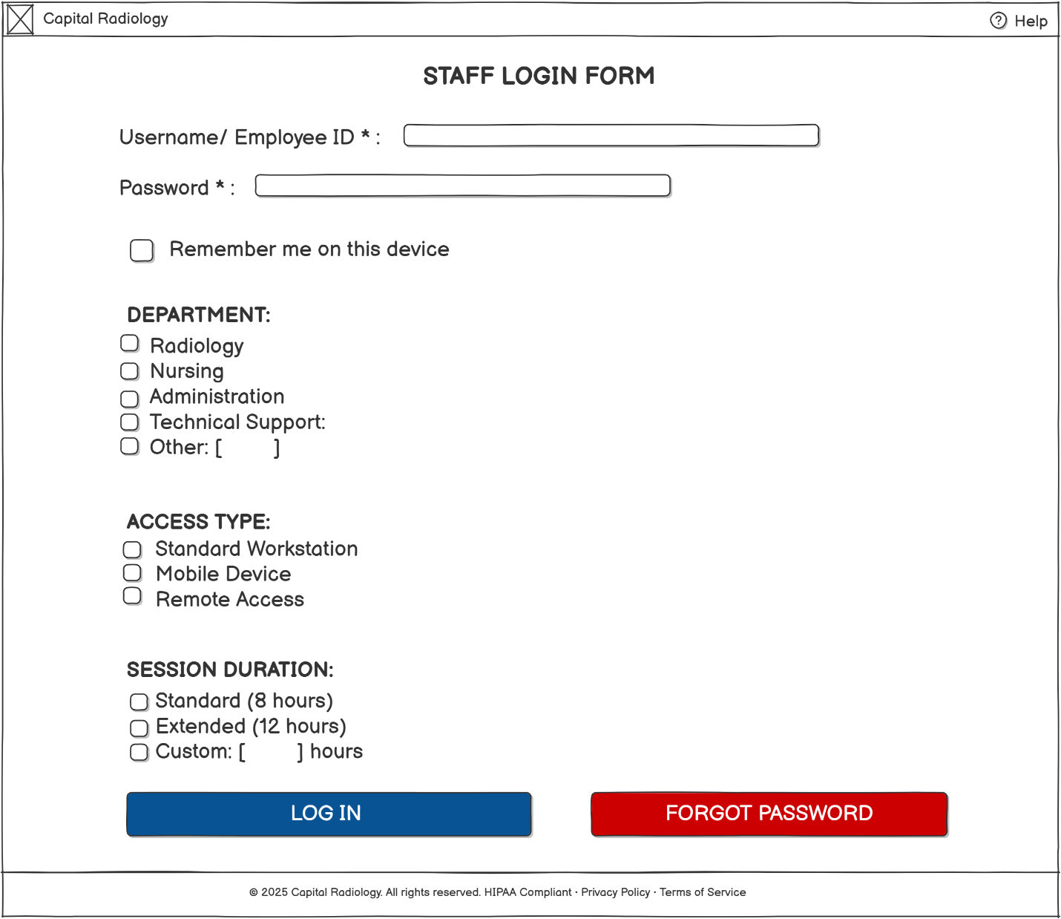

1. **Input Form: Equipment maintenance form**

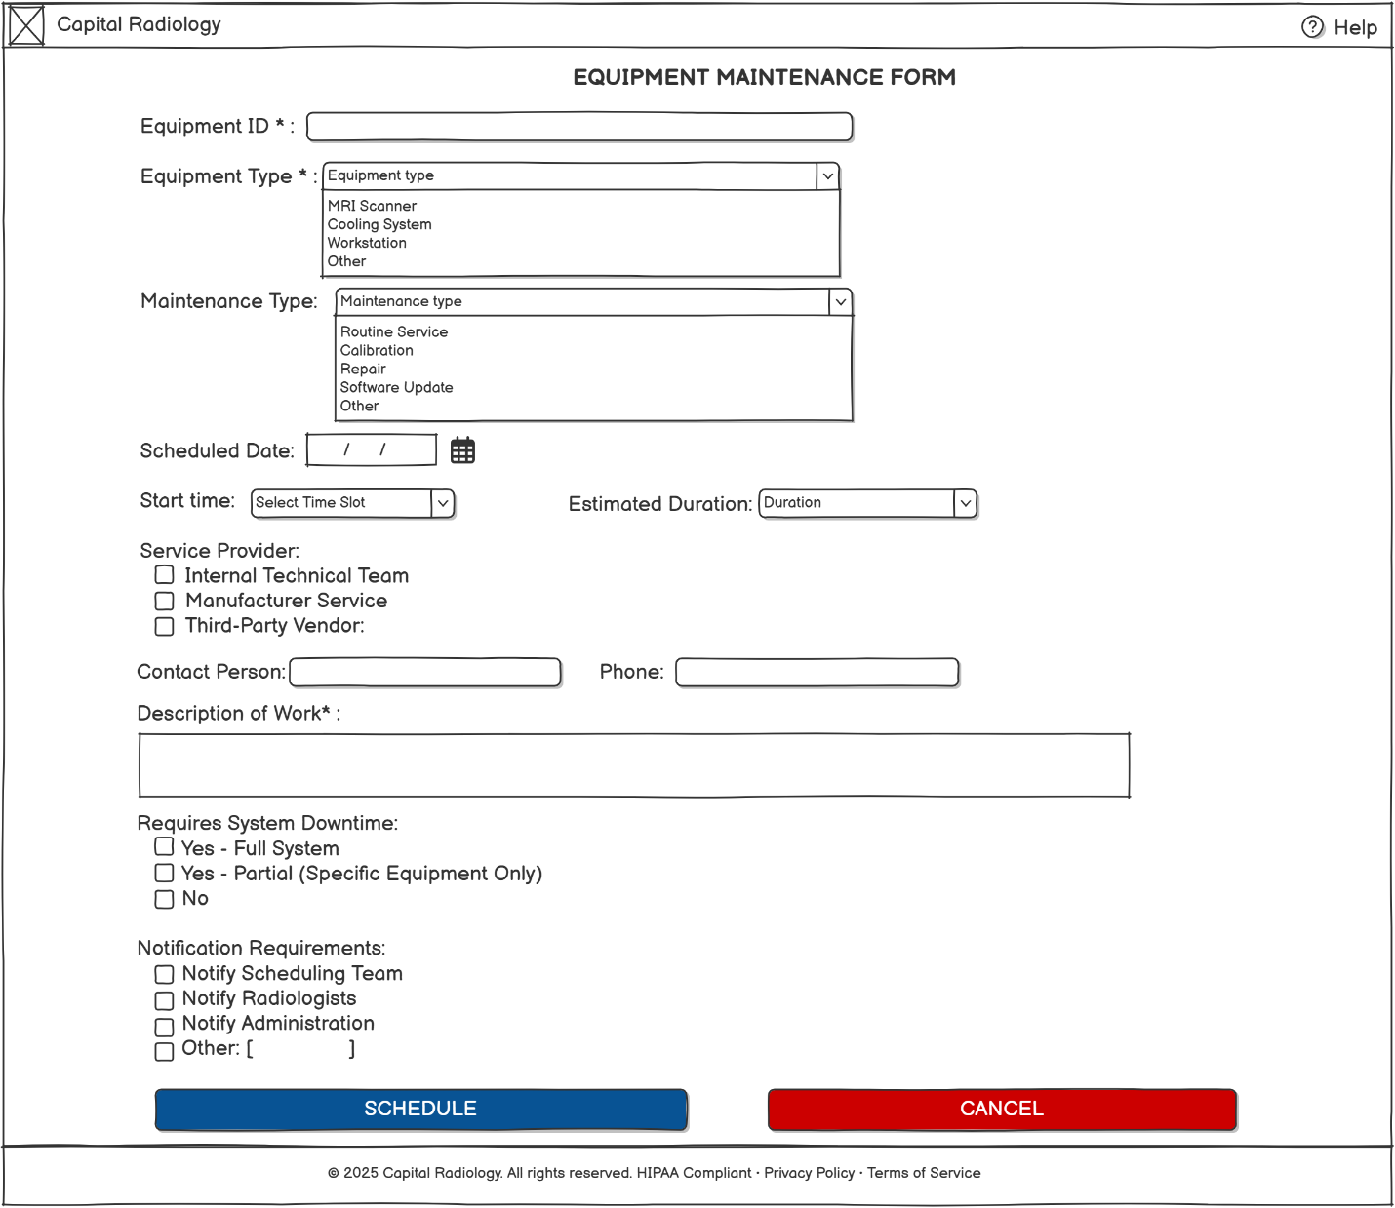

1. **Output Form: Daily activity report**

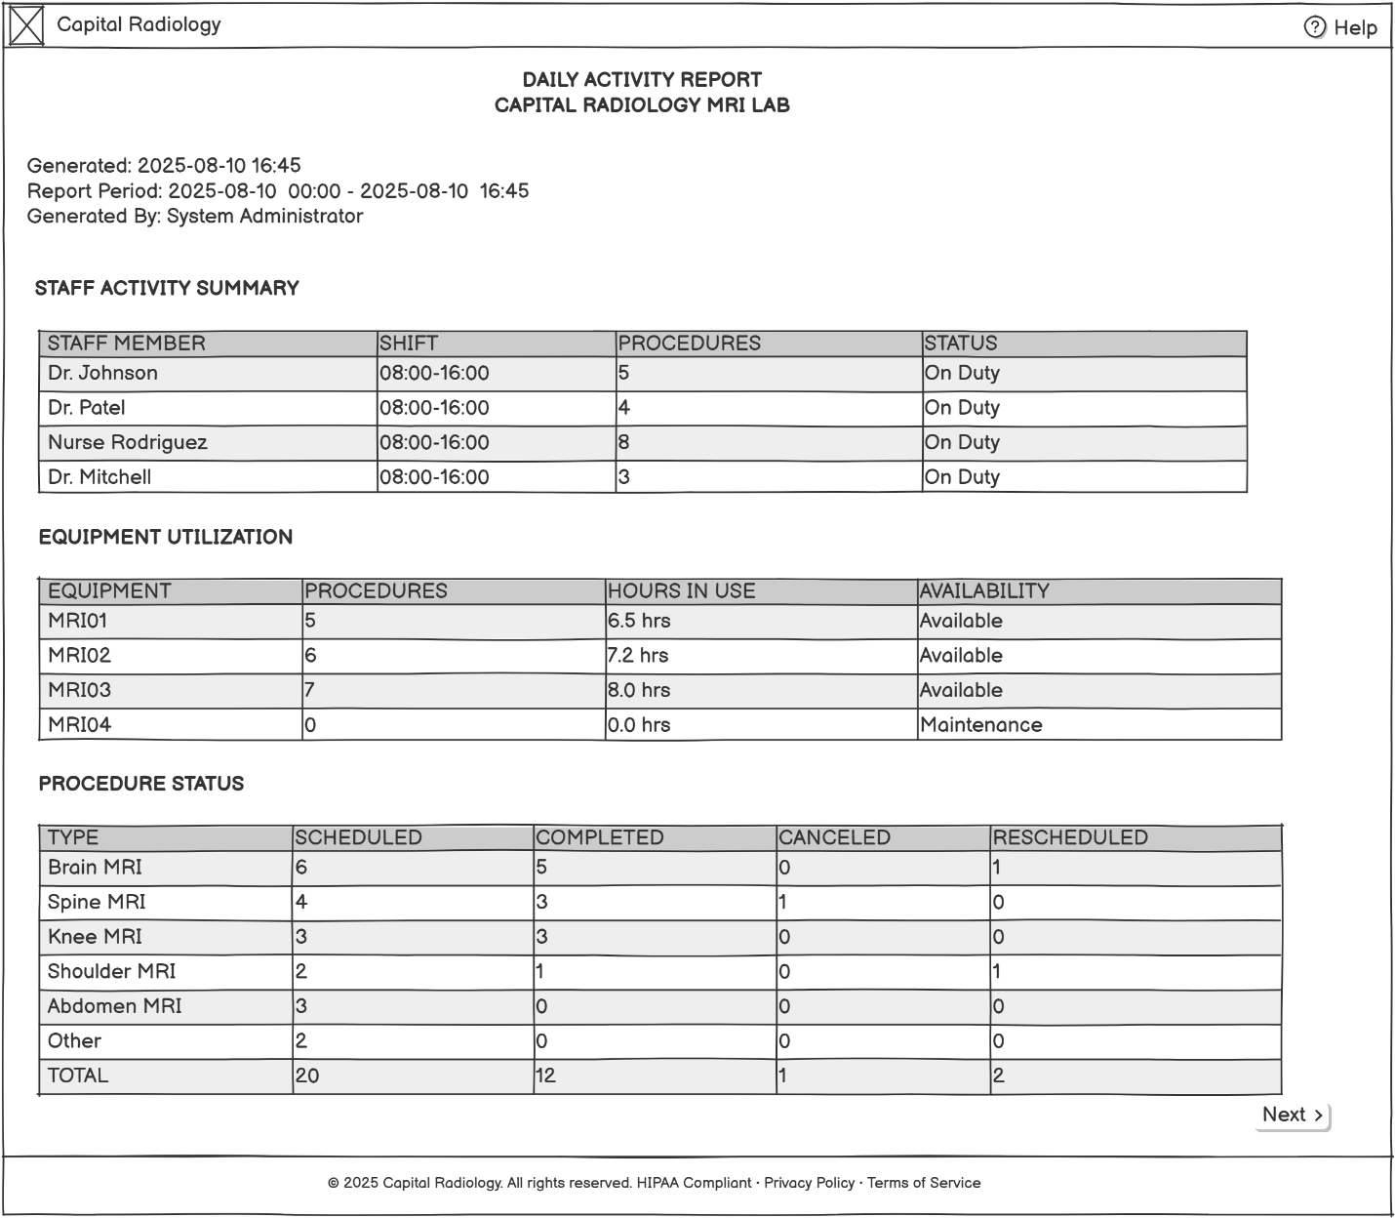

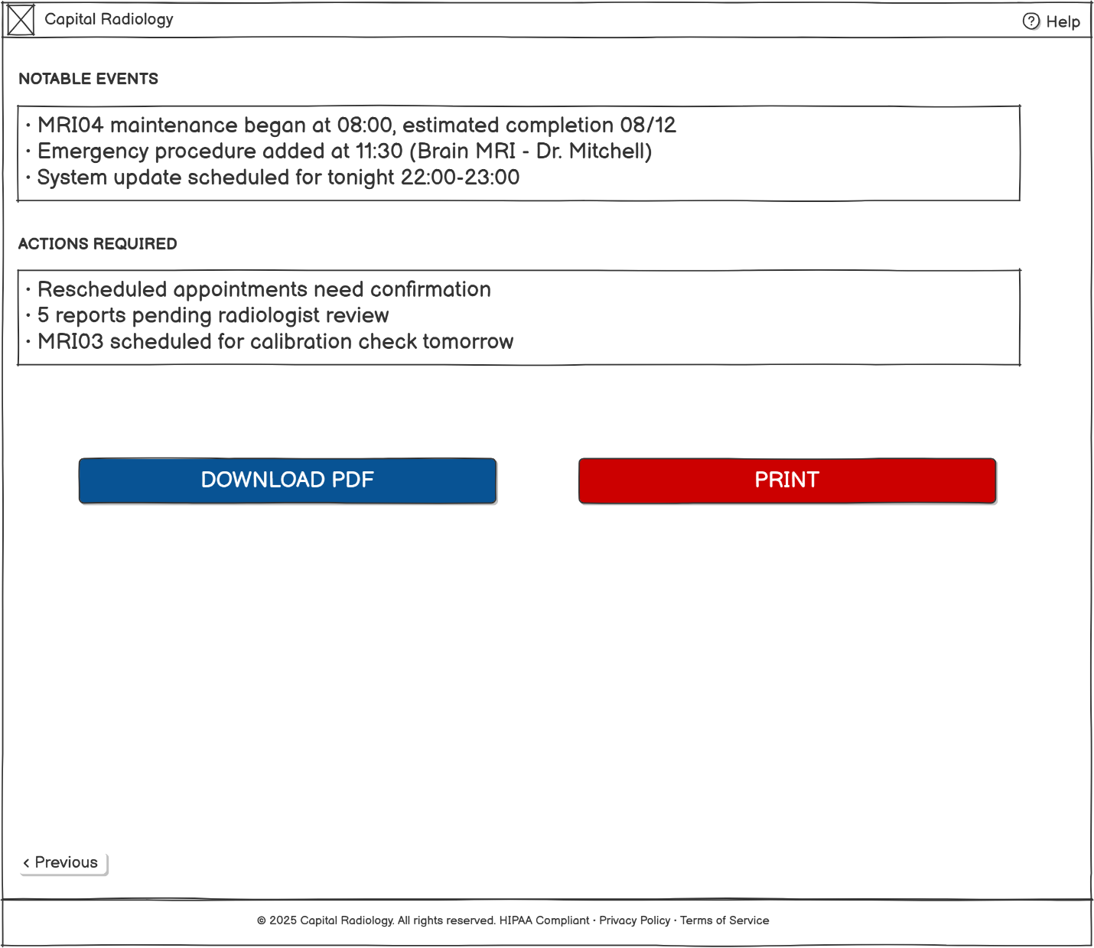

1. **Output Form: Equipment status report**

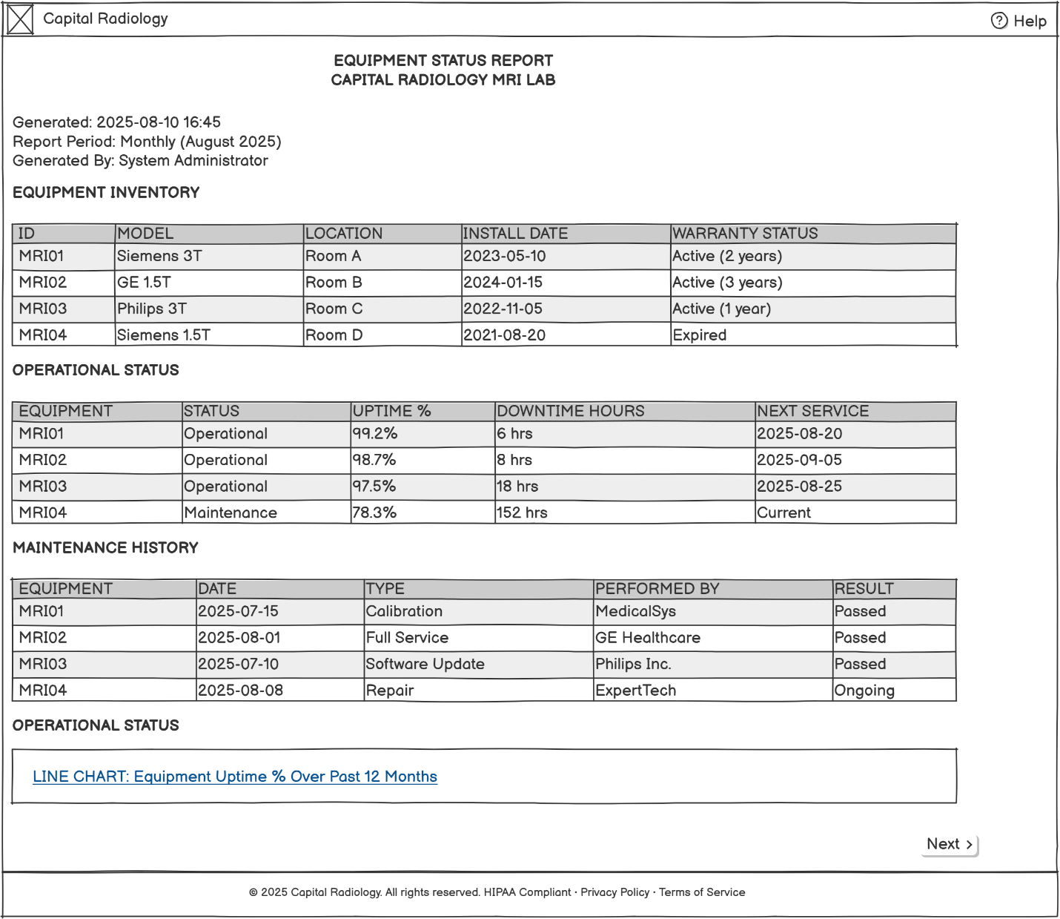

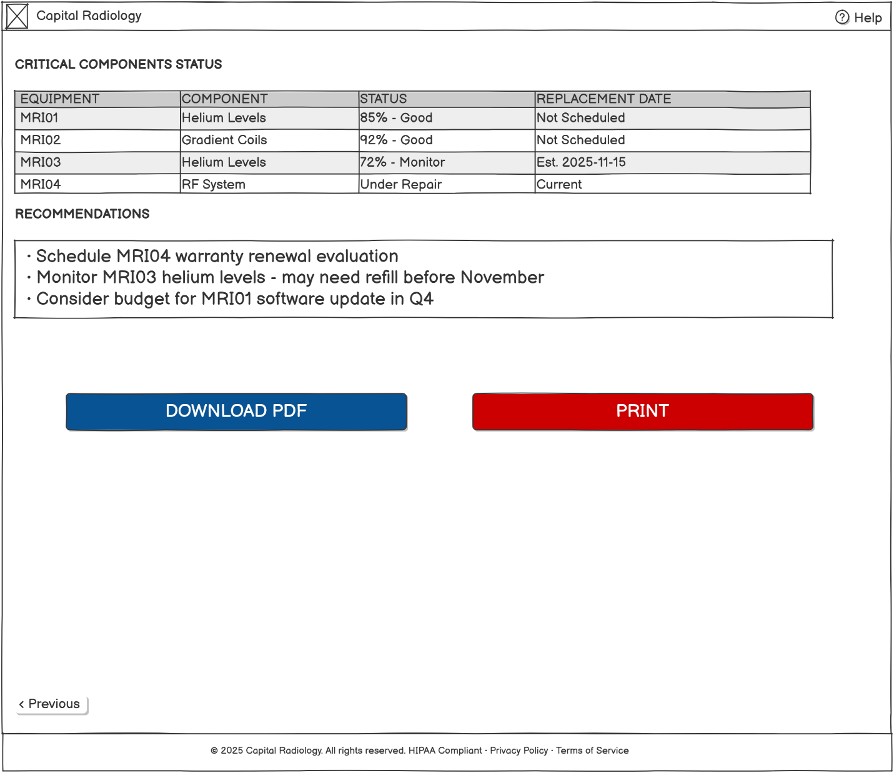

1. **Storyboard: Staff daily workflow management:**

